Chapter 13, Problem 2.

Using Fig. 13.73, design a problem to help other students better understand mutual inductance.
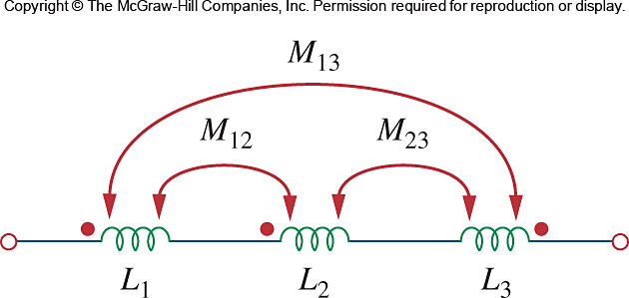

Figure 13.73
For Prob. 13.2.

